Arbuthnott Family Association



Newsletter 2010

Annual Gathering 2010 UK Branch,

This year the annual Gathering will be in London. We will once again be using the officer’s mess at the Inns of Court and City Yeomanry at Lincoln’s Inn. Officer’s Mess, Territorial Army Centre, 10 Stone Buildings, Lincoln’s Inn, London, WC2A 3TG

The Gathering will take place on Friday 29th October, at 6.30pm. The evening will start at 6.30pm, with drinks followed by a short AGM and then a buffet supper. The cost of the evening will be £30.00, including supper. Payment can be made on the evening.

The main purpose of the evening is to meet family and friends and we would welcome and encourage partners and friends to join us.

Please can you complete the reply form to let me know if you are able to come to the gathering, so that I can confirm the arrangements with Julian Allen. My email address is c.arbuthnott@btopenworld.com and telephone number 0131 441 1815.

Annual Gathering in October 2009 in London

First time at Inns of Court officer’s mess, very comfortable location with excellent facilities and a very good supper at a huge refectory table.

The main topic at the AGM was the establishment of the Arbuthnott Heritage Trust. The trust is now set up and is the main feature of this newsletter. The Association has given its full support to the trust and will make a donation of £4,000.

It was also agreed that sales of merchandise should make a larger contribution to the Association funds and that the margin on items sold should be increased.

The Arbuthnott Heritage Trust
(Katherine Allen, May 2010)

This year we set up The Arbuthnott Heritage Trust for the purpose of assisting with the maintenance of Arbuthnott House and the family owned “Arbuthnott Aisle” at the Kirk (Church) of St Ternan, Arbuthnott.

Arbuthnott House is grade A-listed in recognition of its special architectural and historical interest. Of particular cultural significance is the fact that this house has been occupied by the same family since it was first built as a double storey stone keep in c.1242 around the time of Hugh, third Laird of Arbuthnott. It is a great privilege for us to be able to trace back our own family history to an original occupant of the house. All the family should enjoy and feel part of this heritage through the ties of the Family Association.

Arbuthnott Church has a similar lengthy history in that it is one of the few parish churches in rural Scotland that dates from pre-Reformation times and is still in regular use for public worship today. There is every indication that a place of worship existed on the site of the present church, before the chancel was dedicated by David de Bernham, Bishop of St. Andrews, on 3rd August 1242.

Every part of Arbuthnott House is the result of the many generations of development, alteration and reinterpretation of what had gone before to suit the needs of those living there at the time. The present family wishes to continue this process of evolution by making the house suitable for the next 21st century generation to live in and thus safeguard it for future generations. There are extensive renovations planned for Arbuthnott House and Arbuthnott Aisle and this huge amount of work has in fact begun.

Re-roofing of the Family Aisle at Arbuthnott Church
The Arbuthnott Aisle is a beautiful example of late Scottish Gothic building with upper and lower floors constructed by Robert, twelfth laird c. 1482. The lower one, called the Lady Chapel, contains a tomb thought to belong to James Arbuthnott, son of Robert. Tradition has it that the top is the stone effigy of dashing dragon-slayer Hugh le Blond, the fourth laird who died c.1300. The room above the Lady Chapel was destined for the use of the parish priest, James Sibbald, and it would have been in this room that he completed the famous Missal of Arbuthnott in 1491.
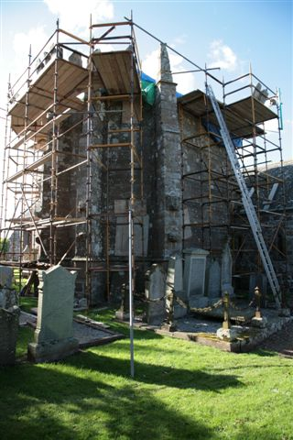
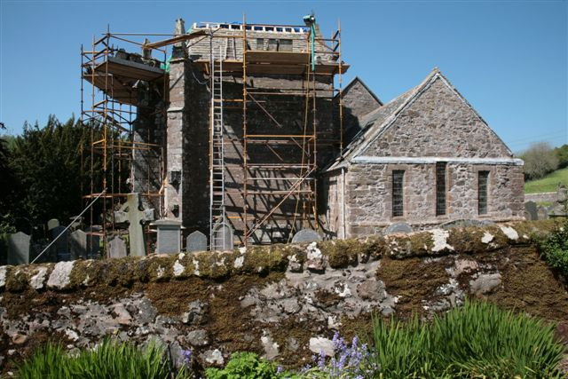
As the roof to this building had been found to be badly in need of repair, a complete rebuild of the wooden structural frame was carried out in 2009, followed by the reinstatement of the original attractive carmyle slates. The work took place over the summer months at a cost of over £26,000.

The scaffolding goes up around the Arbuthnott Aisle.

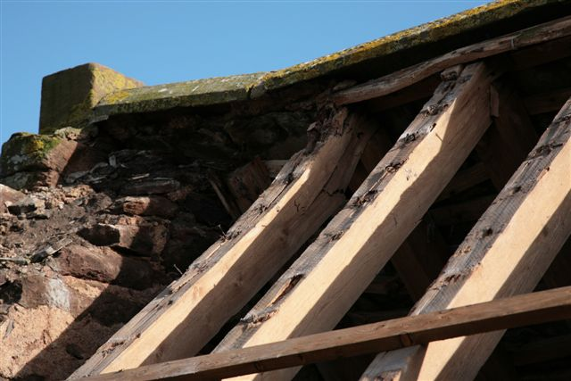
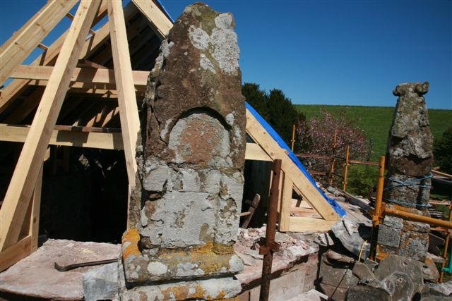
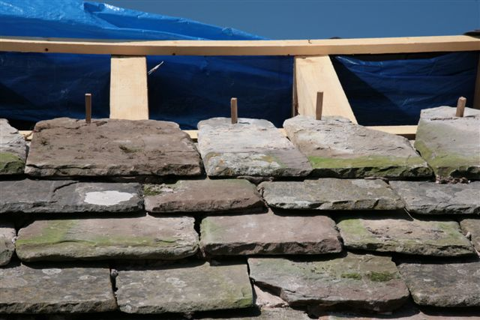

The damaged structural framework of the roof is replaced with new timber.
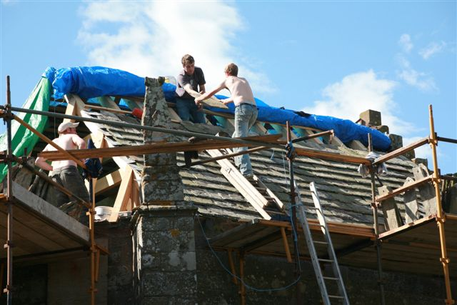

The original carmyle slate roof tiles are fixed back into place.

Renovations at Arbuthnott House

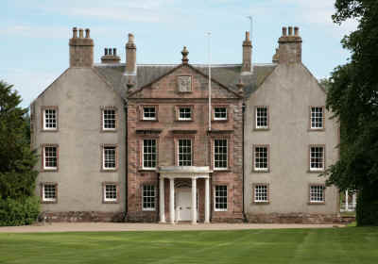
The present house is an 18th century enlargement of a 17th century dwelling, which in turn grew out of periods of development in the 15th and 16th century of a fortified manor-house. All that now remains of the original 13th century structure is a small section of wall at the base of an outbuilding; however the existing structure is a record of the many alterations and additions made to suit the requirements, fashions and changing fortunes of each new generation in their family home.

Wear and Tear along with Time have taken their toll on the fabric of the building and the needs of the 21st century (such as central heating!) are urgently required to retain the house as a family home and a focus for all Arbuthnot(t)s throughout the world.

The Outside
The roof is in need of extensive repair and strengthening, as many of the beams are significantly damaged by worm and decay.
The cement harling (render) is to be removed and replaced with a lime mortar to let the building breathe.
The sandstone at the Georgian frontage of the house is much weathered and will be tidied up and restored.
A new water house is to be built to provide a pressurised system and do away with the fragile attic water storage as at present.

The Inside
The house requires to be emptied of all furniture for a year to permit:
- Strengthening and repair of all first and second room floors – many are excessively bouncy with great dips in them, particularly where these floors support important moulded plaster ceilings below.
- Renewal and upgrade of all services at the house (e.g. hot and cold water distribution, bathrooms, electricity and drainage)
- Installation of a complete central heating system using renewable wood pellets as fuel that, as well as being an economical fuel, are sourced and manufactured on the Arbuthnott Estate.
- Reconfiguration of the informal living accommodation on the ground floor to suit a modern lifestyle, including the creation of a new kitchen and family living space on the south side of the building (presently on the north side), a purpose-built replacement library room and new utility spaces.

These proposals will greatly enhance the house, making best use of the existing accommodation, retaining the character of the house and creating a pleasant and comfortable home to live in, while safeguarding the historic fabric and the continued occupancy of the house.

The Family Association supports the Heritage Trust and will make a contribution to start the funds. We would like to ask you to consider making a donation to support these projects and to help preserve our family’s heritage for the future. The Trust status means that there will be clear visibility as to how the funds are being used. We will keep you informed of this and send you news of the progress of the renovations. Work is due to begin in the summer of 2010 and it is our earnest hope that by the International Family Gathering in 2013, the work will have been finished and we will be able to show you the results.

If you would like to make a donation, please make a cheque out to “The Arbuthnott Heritage Trust” and send it to our Association Treasurer, John Arbuthnott, The Old Schoolhouse, Luppitt, Honiton, Devon EX14 4RT.

Family Website,

The family genealogical website has proved to be an excellent source of information for all Arbuthnot(t)s. Anyone who has not had a chance to view the site should register on line with www.kittybrewster.com Please contact either myself, c.arbuthnott@btopenworld.com or Sir William Arbuthnot, Family Genealogist, arbuthnot@kittybrewster.com if you have any items of family news which should be added to the website.

Merchandise

There is a stock of merchandise held for sale which includes woollen scarves, ties, bow ties, woollen shawls, silk head squares, travel rugs and photo frames. All made in tartan.

The tartan cloth is stored by the weaver at the mill and can be ordered from the secretary to be sent out direct.

All enquiries to c.arbuthnott@btopenworld.com or telephone number 0131 441 1815

Newsletter by E-mail.

The database of e-mail addresses is increasing and I am keen to capture as many as possible so that the newsletter can to distributed electronically to as many people as possible.

If you receive the newsletter in black and white by post and you would like to receive a colour copy by e-mail, please can you send me your e-mail address? Also, there maybe some people who receive the newsletter twice, once by post and secondly by e-mail, again please let me know and I will stop the postal copy.

Please can you send me your e-mail address to c.arbuthnott@btopenworld.com

Charles Arbuthnott 0131 441 1815 May 2010
7A Woodhall Bank, Edinburgh EH13 0HL

Reply Form.

Name
Address

Telephone number
e-mail address

Family Gathering Friday 29 October 2010

Yes, I will be attending the Gathering on Friday 29th October in the Inns of Court and City Yeomanry Officer’s Mess.

Cost £30.00 per person How many? ……..

Please return to Charles Arbuthnott
7A Woodhall Bank
Edinburgh
EH13 0HL

e-mail c.arbuthnott@btopenworld.com

telephone number 0131 441 1815

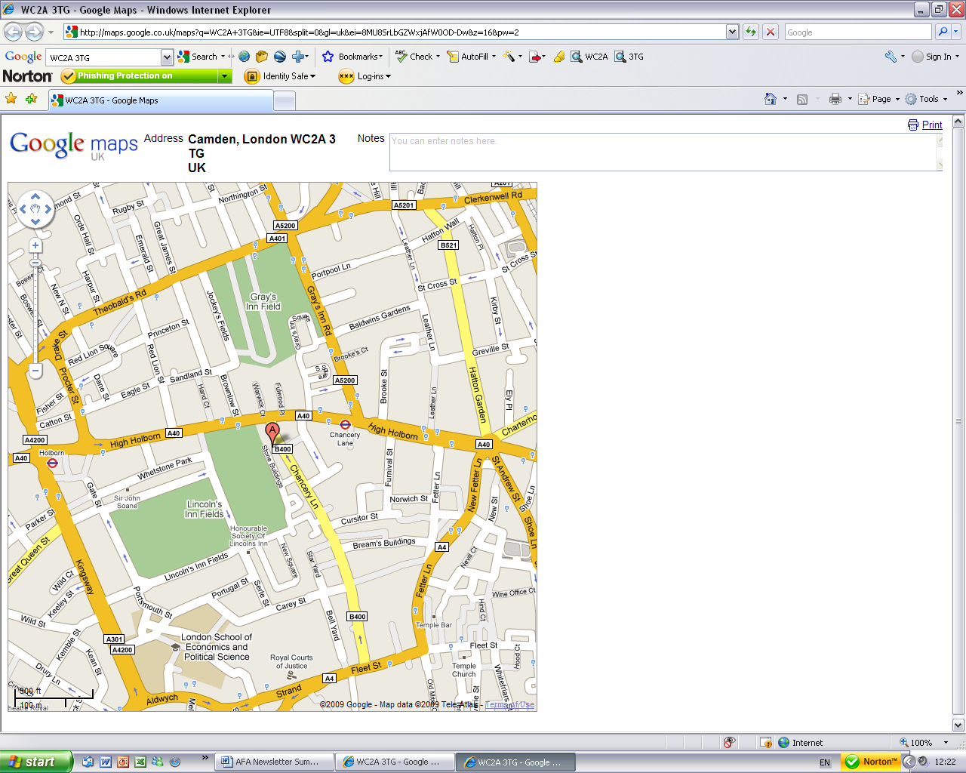
By car:
Lincoln’s Inn lies off A4200 Kingsway and A40 High Holborn. The entrance gate is through an arch on the east side of Lincoln’s Inn Fields. Please ask for 10 Stone Buildings and you will be directed to the car parking spaces outside.

By tube:
The nearest tube is Holborn on the Central line.
Walk round Lincoln's Inn Fields to the east side. Turn left through the arch into New Square. Turn left again after the War Memorial. Walk past the chapel on your right. You will come to a cul de sac lined with terraced houses on either side. 10 Stone Buildings is up on your right next to the Territorial Army sign.

10, Stone Buildings, Lincoln’s Inn, London, WC2A 3TG

